Chairman’s Report 2018/2019

Brookthorpe-with-Whaddon Parish Council

First, I would like to thank you all and the Parish Council for your attendance this evening.

Some special thanks past and present goes to Anne Szabo (our clerk) for her continued support and expertise in many subjects related to the Parish Council’s wellbeing.

Thank you to the following for their past and continued support.

* Village Hall Committee.
* County Councillor.
* District Councillors,
* Village Wardens.
* Local Police for their support.
* Eric Hibbert Website.
* Paul Gaze for all that he gives back to the village.
* The small number of the Parish who attend meetings and have contributed

whenever possible.

The last year has been a challenging year for the Parish Council and I personally would like to thank them all for joining this great parish we all live in and love.

We also have a new member who I would like to thank and welcome, Coleen Ferris on to the parish Council, and would also like to thank Gordon Simpson who has now resigned and would personally like to thank Gordon for the past seven years he gave the Parish Council. I wish Gordon all the best for the future.

* Steve Betts (Chairman).
* John Hendry (Vice Chairman).
* Lynda King.
* Dave Kasper
* Coleen Summers
* Vacant (Any Volunteers)

It has been a big and challenging year for the council members. However, in the past year we have dealt with the following:

**Essential replacement and repairs**

**GRANTS – Issued**

Memorial 1WW Bench – Stone – Replacement Flag Pole £3234.00

Village Hall £2000.00

Community Events £2500.00

St Margaret’s, £360.00

St Swithuns £1000.00-£500.00 of which was held over from previous year.

**Precept £13750.00**

**PLANNING –**

Several applications were passed although several objections were made and many rejected.

I strongly believe that SDC need to be more supportive and understanding when dealing with planning applications that are affecting residents within Brookthorpe-with-Whaddon Parish.

We need to keep focused on the current planning in relations to the MSA proposal 74 Bed Hotel

And also the WhaddonFields Development**. For full details please see the new newsletter**



**Traveller’s site** some improvement has been made. But Stroud District Council going forward need to take more of an active role in the management of the site and the safety to the Parish.

**Burglaries.** There has been a massive increase over the past twelve months in break-ins affecting house dwellings, out buildings, farms, and agriculture businesses. The focus this year will be finding ways to improve and protect the Parish.

**Verge Cutting.** One extra cut per year will be carried out after raised concerns were made by the public in relations to safety and visibility. This was implemented and the feedback was positive. This will be on going. We ae now in contract with a new contractor that gives the Parish full control for these services.

**St Swithuns Church.** Over several months now the church has fallen victim to damage to the church grounds and also the carpark being used for all unsavoury events & activity .The parish council will fully fund and have now instructed a Carpenter to fit and supply a pair of gates constructed in Iroko timber, hung on green oak posts at the entrance to the car park area. These will be installed by the end of June.

**Village Phone Box**. Brookthorpe-with-Whaddon are now the proud owners of our beloved Red phone box all for the cost of £1.00. Within the next twelve months our village phone box will be restored and relocated within the village hall grounds. It will also be the new home for the Defibrillator.

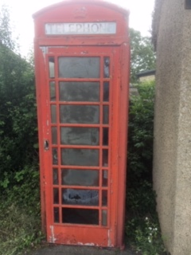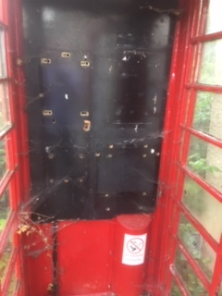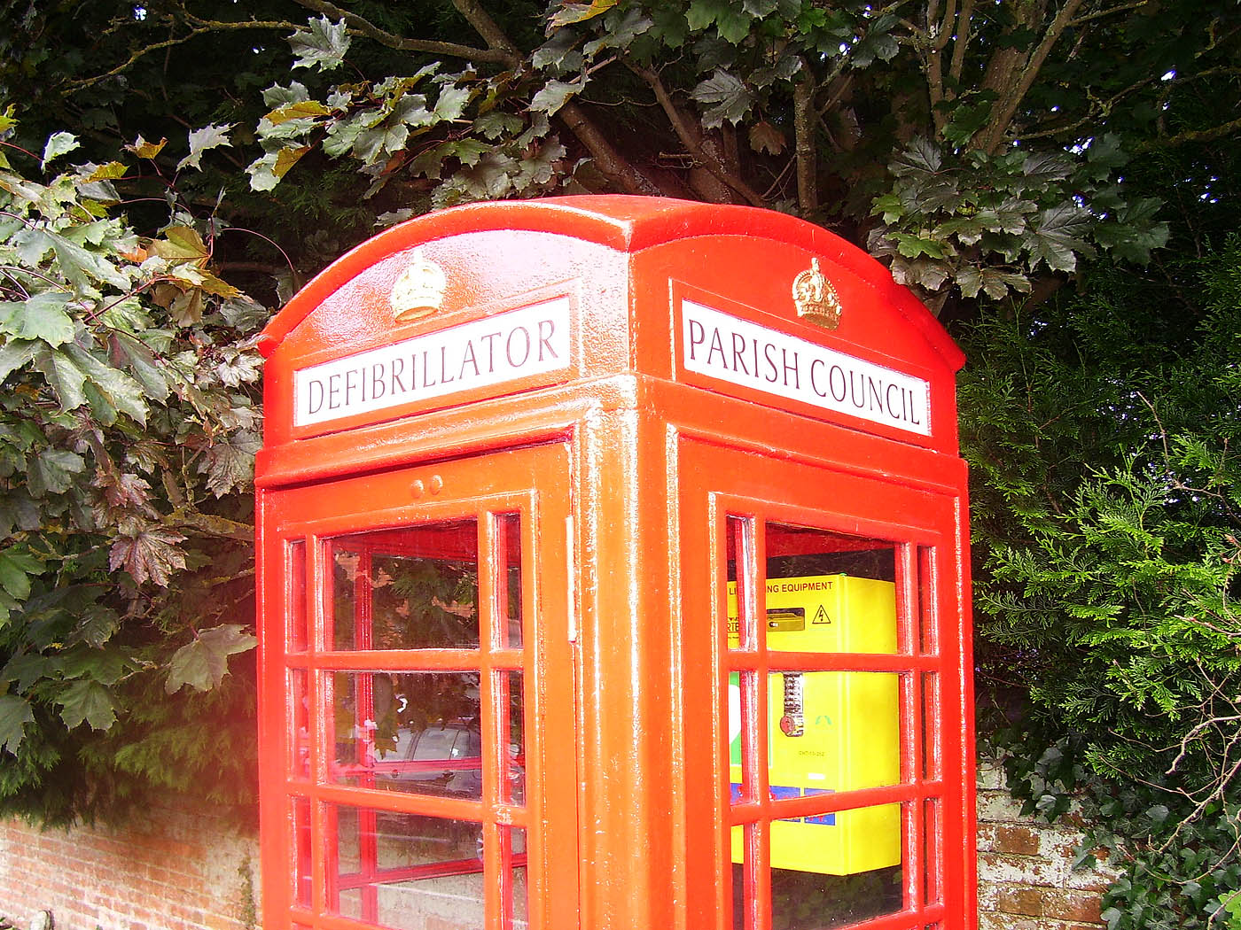

**Bus Stop Maintenance**

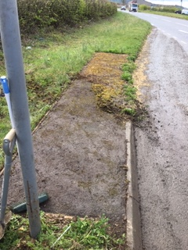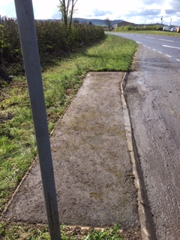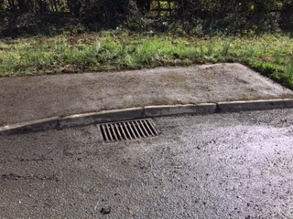

**Bus Shelter Maintenance.**

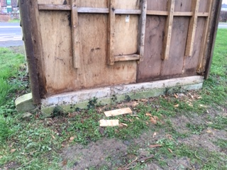

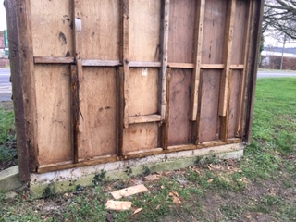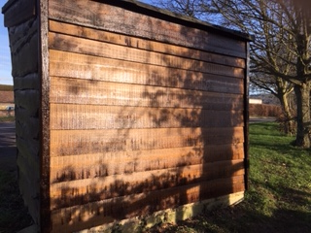

I will continue to do my best in serving the parish and thank you all for your time this evening.

Kind regards

Steve Betts - Chairman Brookthorpe-with-Whaddon Parish Council.